**ANGULAR 15**

**Angular Architecture**

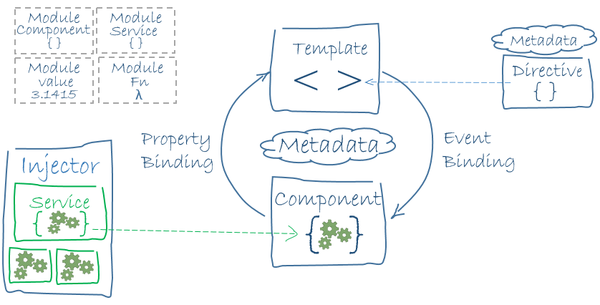

* SPA : Single Page Application
* AngularJS : Controller & Scaope
* TypeScript
* Dart, js, ecma script etc…

1. Node to be installed.
2. NPM : Node Package Manager – all the dependencies for the angular application.
3. Npm install -g @angular/cli
4. Ng new storeapp
5. Ng serve
6. To change the port number: ng serve - -port 4300

The angular.json file at the root level of an Angular workspace provides workspace-wide and project-specific configuration defaults.

These are used for build and development tools provided by the Angular CLI.

The presence of a tsconfig.json file in a directory indicates that the directory is the root of a TypeScript project.

The tsconfig.json file specifies the root files and the compiler options required to compile the project.

The package.json file contains the metadata information. It basically consist of the properties to identify the module/project such as the name of the project, current version of the module, license, author of the project, description about the project etc.

DATA BINDING:

* Communication
* Between Model and View
* Types of Binding
  + Interpolation – One {{}}
  + Property Binding – One []
  + Event Binding – One ()
  + Property + Event – Two [], ()
  + One Way binding - {{}}, [] , ()
  + Two way binding [()], ngModel

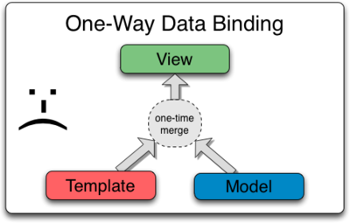

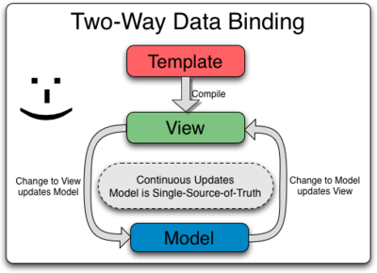

Steps for angular CLI installation:

1. **npm uninstall -g @angular/cli**
2. **npm cache clean –force**
3. **npm install -g @angular/cli@15**
4. **ng --version**

**DIRECTIVES IN ANGULAR:**

* Directives are also component but without View.
* Component without template
* It is used to manage the DOM



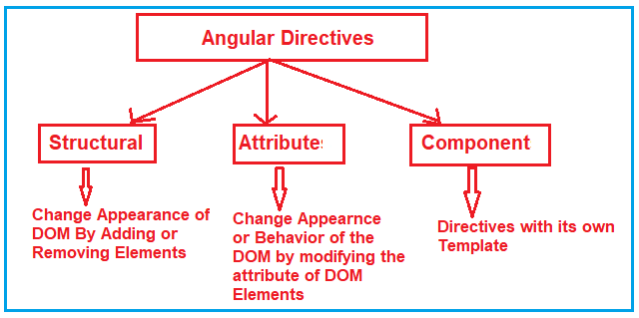

* Attribute Directive: behavior or appearance of the element.
* Structural Directive: modify the structure od the DOM by adding or removing the elements.
* Component Directive: Components defined with logic and has template.

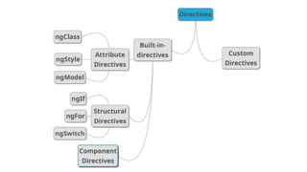

**STRUCTURAL DIRECTIVES:**

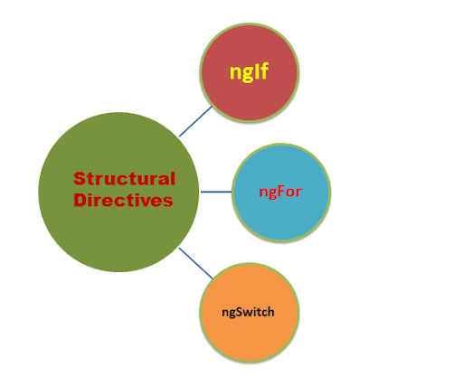

ATTRIBUTE DIRECTIVES:

**ngClass**

**ngModel**

**ngStyle**

**Attribute Directives**

* + **NgClass**—adds and removes a set of CSS classes.
  + **NgStyle**—adds and removes a set of HTML styles.
  + **NgModel**—adds two-way data binding to an HTML form element.

**<ng**-template> - It is mostly used with Structural directives and also with custom directives.

ngSwitch:

1. ngSwitch
2. ngSwitchCase
3. ngSwitchDefault